# DIS-AM,C- Taino - Zemi frigate bird marker

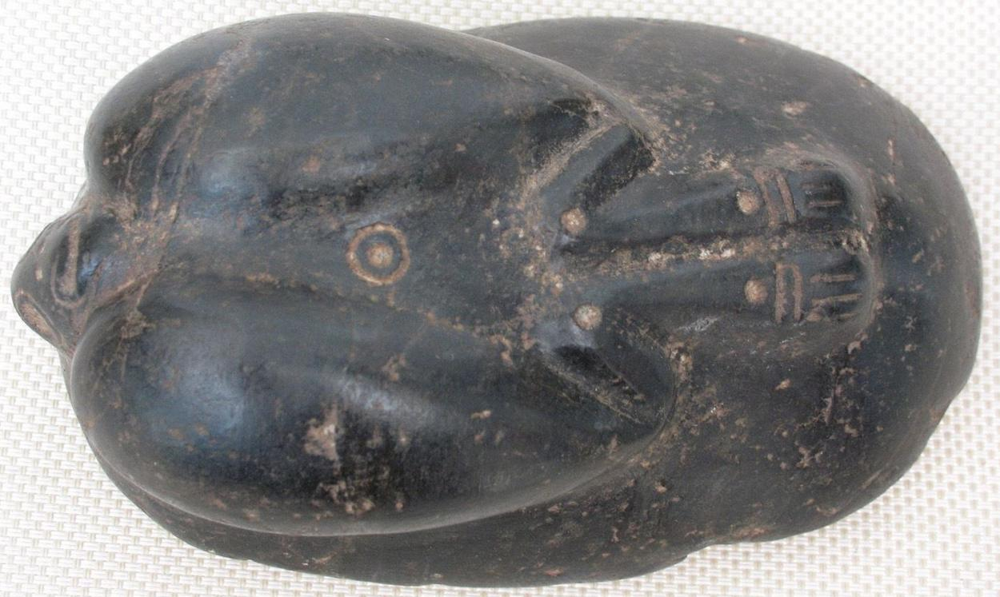 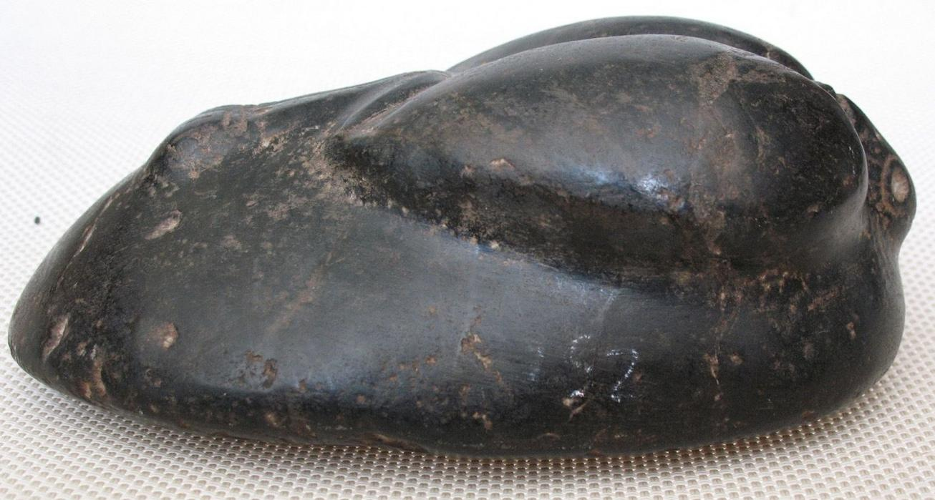 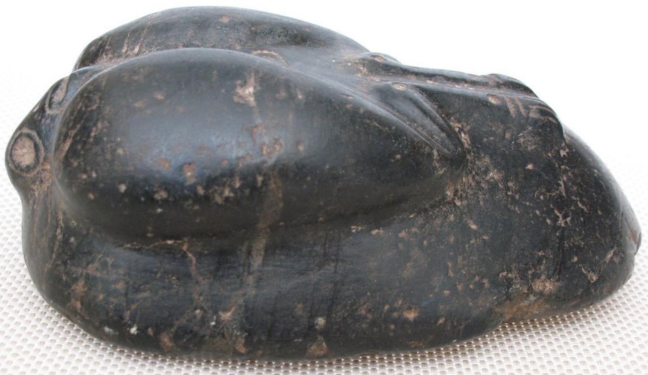

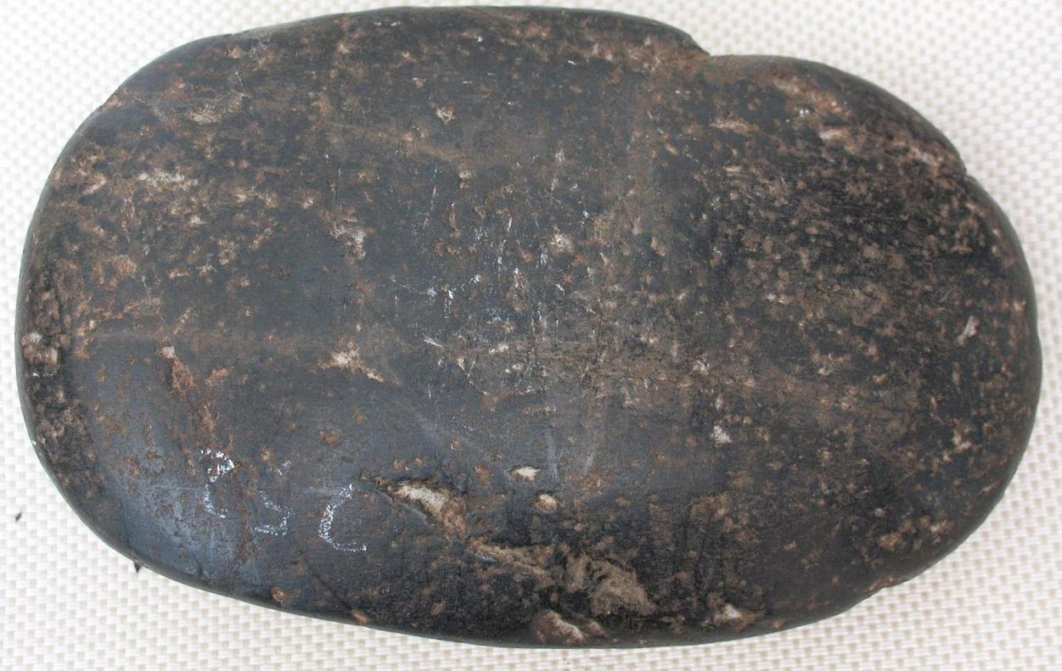

Item condition:

--not specified

Ended:

Sep 30, 2015 , 5:21PM

Winning bid:

US $250.00

[ [1 bid](http://offer.ebay.com/ws/eBayISAPI.dll?ViewBids&item=201433872268&rt=nc&_trksid=p2047675.l2565) ]

|  |  |
| --- | --- |
|  | Join **eBay Bucks** and earn **%** back on this item. [See conditionsfor eBay Bucks - opens in a new window or tab](http://pages.ebay.com/rewards/terms.html?ssPageName=STRK:VI:LNLK:TCS) |

Shipping:

$15.00 E